React shared documents session

For SImple React Project

* Refer doc :: <https://javascript.plainenglish.io/how-to-share-and-reuse-react-components-to-build-apps-faster-4b3b0b542798>
* Steps
  + npx create-react-app my-app
  + npm install bit-bin -g
  + Open bit. dev site
  + Select bit. cloud on navbar
  + bit init (make sure u have logged in on dev)
  + bit login
  + bit add srcbit import bit.envs/compilers/react --compiler
    - Shows
      * the following component environments were installed
      * - bit.envs/compilers/react@0.0.14
  + bit tag --all 1.0.0
  + bit export nsoni.<collectionName>
  + Refresh the bit cloud page and check the code is there or not
  + Check on components

For React Portlet

* Refer doc :: <https://liferay.dev/blogs/-/blogs/how-to-use-shared-library-javascript-with-react-in-liferay>

Node with docker compose file

Steps::

* Create a folder
* Add docker-compose.yml file
* version: '2'
* services:
* backend:
* image: node:14.19.3
* container_name: docker1
* volumes:
* - ./app/:/usr/src/app
* environment:
* PORT: 8083
* ports:
* - 8081:8080
* command: ['sh', '-c', 'cd /usr/src/app && npm i express && npm run start']
* Create folder using npm init
* Create folder name src
* Create index file on src folder

const express = require('express');

const app = express();

app.get("/",(req,res)=>{

res.send(console.log("workable yeah !!!"))

})

app.listen(process.env.PORT || 8080, (err) => {

!err ? console.log('Server listening on Port', process.env.PORT) : console.log('Error in server setup');

});

Folder structure

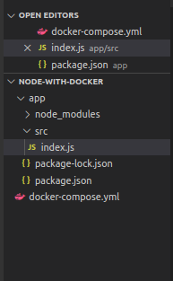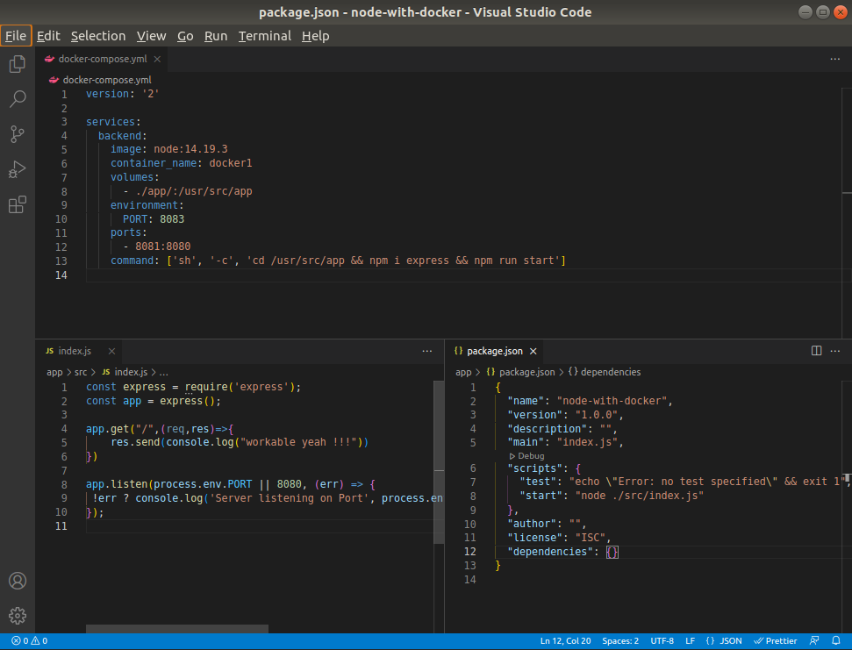

Sequellized Using Postgresql

* Refer Doc except teo lines
  + <https://www.pgadmin.org/download/pgadmin-4-apt/>
  + Pgadmin4 :: https://www.tecmint.com/install-postgresql-and-pgadmin-in-ubuntu/
* Opn cmd
  + curl https://www.pgadmin.org/static/packages_pgadmin_org.pub | sudo apt-key add
  + sudo sh -c 'echo "deb https://ftp.postgresql.org/pub/pgadmin/pgadmin4/apt/$(lsb_release -cs) pgadmin4 main" > /etc/apt/sources.list.d/pgadmin4.list && apt update'
  + sudo apt install pgadmin4
  + Check this command
    - ->sudo systemctl is-active postgresql
    - ->sudo systemctl status postgresql
    - ->sudo pg_isready
    - ->sudo su - postgres
    - ->psql
    - ->ALTER USER postgres WITH PASSWORD 'postgres';
  + Open pgadmin4
  + Password – postgres
  + Create new server
    - General Name:: node-sequellized
    - Connection :: 127.0.0.1
    - Save